A MINI PROJECT REPORT ON

**ALERT SYSTEM FOR PARENTS FROM FAST MOVING STUDENT VEHICLES USING WIRELESS SENSOR NETWORK**

A dissertation submitted in partial fulfilment of the

Requirements for the award of the degree of

**BACHELOR OF TECHNOLOGY**

in

**COMPUTER SCIENCE AND ENGINEERING**

***Submitted by***

**PASHAM AVINASH REDDY 18B81A05J6**

**VANAM SAI SHANKAR 18B81A05M9**

**PASUNOORU SANTOSH REDDT 18B81A05N0**

***Under the esteemed guidance of***

DR. A. SRINIVAS REDDY

Associate Professor, CSE Department

CVR College of Engineering



**DEPARTMENT OF COMPUTER SCIENCE AND ENGINEERING**

**CVR COLLEGE OF ENGINEERING**

**(*An Autonomous institution, NBA, NAAC Accredited and Affiliated to JNTUH, Hyderabad*)**

Vastunagar, Mangalpalli (V), Ibrahimpatnam (M),  
Rangareddy (D), Telangana- 501 510

**June 2021**

**DEPARTMENT OF COMPUTER SCIENCE AND ENGINEERING**

**CERTIFICATE**



This is to certify that the project entitled “**Alert System For Parents From Fast Moving Student Vehicles Using Wireless Sensor Networks**” that is being submitted by **Pasham Avinash Reddy (18B81A05J6), Vanam Saishankar (18B81A05M9), Pasunooru Santhosh Reddy (18B81A05N0)** in partial fulfillment for the award of Bachelor of Technology in Computer Science and Engineeringto the CVR College of Engineering, is a record of Bonafide work carried out by them under my guidance and supervision during the year 2020-2021.

The results embodied in this project work have not been submitted to any other University or Institute for the award of any degree or diploma.

Dr. A. Srinivas Reddy Mrs. A. Vani Vathsala

Associate Professor, CSE HOD, CSE

CVR College of Engineering CVR College of Engineering

External Examiner

**DECLARATION**

We hereby declare that the project report entitled “**Alert System For Parents From Fast Moving Student Vehicles Using Wireless Sensor Networks**” is an original work done and submitted to CSE Department, CVR College of Engineering, affiliated to Jawaharlal Nehru Technological University Hyderabad, Hyderabad in partial fulfilment of the requirement for the award of Bachelor of Technology in **Information Technology** and it is a record of Bonafide project work carried out by us under the guidance of **Dr. A. Srinivas Reddy, Associate Professor, Department of Computer Science and Engineering.**

We further declare that the work reported in this project has not been submitted, either in part or in full, for the award of any other degree or diploma in this institute or any other Institute or University.

**Pasham Avinash Reddy**

**(18B81A05J6)**

**Vanam Saishankar**

**(18B81A05M9)**

**Pasunooru Santhosh Reddy**

**(18B81A05N0)**

**ACKNOWLEDGEMENT**

The satisfaction of completing this project would be incomplete without mentioning our gratitude towards all the people who have supported us. Constant guidance and encouragement have been instrumental in the completion of this project.

First and foremost, we thank the Chairman, Principal, Vice Principal for availing infrastructural facilities to complete the mini project in time.

We offer our sincere gratitude to our internal guide **Dr. A. Srinivas Reddy,** Associate Professor, CSE Department, CVR College of Engineering for his immense support, timely co-operation and valuable advice throughout the course of our project work.

We would like to thank the Head of Department, Professor: **Mrs. A. Vani Vathsala**, for his meticulous care and cooperation throughout the project work.

We are thankful to **Mr. D. Sujan Kumar,** Project Coordinator, Professor, CSE Department, Section Co-Ordinator: **Ms. Ch. Bhavani, Mr. Nagaraju**, Associate professors, CVR College of Engineering for their supportive guidelines and for having provided the necessary help for carrying forward this project without any obstacles and hindrances.

We also thank the **Project Review Committee Members** for their valuable suggestions.

**Pasham Avinash Reddy (18B81A05J6)**

**Vanam Saishankar (18B81A05M9)**

**Pasunooru Santhosh Reddy (18B81A05N0)**

**ABSTRACT**

The goal of this paper is to analyze the vehicle movement and alerting the parents which is a challenging problem. Now a day’s students are using two-wheeler vehicles lot more than books in education. The main problem is the speed with which they are driving the vehicles. We are seeing daily in news that many accidents are getting happened and many students are dying every day. RFID (Radio Frequency Identification) is chosen as one of technology implemented for vehicle monitoring system. GSM (Global System for Mobile Communication) is most widely used for alerting system. Alerting system is essential for providing the location and information about vehicle to passenger, owner or user.

In this paper, we propose a method where parents are controlling the speed of vehicles. When the student is driving the vehicle with speed more than 60 KMPH, the alert system sends a message to the parent. Now parent can take actions to reduce the speed. In this scenario, there must be provision where parents are controlling the speed and there must be alert system which sends the message if speed is exceeding the limits. These things can be done by the manufacturer of vehicles themselves, but for practical use we can’t limit the speed of emergency vehicles like ambulances, fire engines etc. so we propose a method where parents are taking active participation in this and controlling their wards regarding the speed. This also saves lot Fuel energy and air pollution can be minimized.

**TABLES OF CONTENT**

**S. No Topic Pg. No**

**1 Introduction…………………………………………………….………………………. 1**

**2 Literature Survey …………………...…………………………………………… 3**

**3 Software & Hardware specifications …………………………………………… 4**

**4 Proposed System Design……………………………………………………………. 5**

**5 Implementation and Testing ……… ……….......................................................... 10**

**Conclusion……………………………………………………......................................... 34**

**Future Enhancements…………………………………………………........................ 35**

**References………………………………………………….............................................. 36**

**Appendix A - Abbreviations…………………………………………………........... 37**

**Appendix B - Software Installation Procedure………………………………... 38**

**Appendix C – Software Usage Process…………………………………………... 47**

**Annexure 3**

**List of Tables**

Table Title Page

3.1 Values Assigned to Standard kε Turbulence Model Coefficients ...... 55

3.2 Values Assigned to RNG kε Turbulence Model Coefficients .............. 57

4.1 Engine Specifications........................................................................... 90

4.2 Geometrical Details of the Injector....................................................... 90

4.3 Boundary and Initial Conditions .......................................................... 94

4.4 Grid Independence Study...................................................................... 99

**Annexure 4**

**LIST OF FIGURES**

Figure Title Page

3.1 Lagrangian Droplet Motion ............................................................................... …70

4.1 Vertical Manifold..................................................................................................... 95

4.2 200 Bend Manifold.................................................................................................. 95

4.3 900 Bend Manifold.................................................................................................. 95

4.4 Spiral Manifold........................................................................................................ 95

4.5 Spiral Manifold Configuration …………………………………………………….97

**Annexure 5**

**SYMBOLS**

Symbols

A Pre-exponential constant

Ad Droplet cross-sectional area, m2

As Droplet surface area, m2

A0 Nozzle cross sectional area. m2

Cp Specific heat, J/kg-K

Cam Reaction progress variable

C Coefficient of discharge of nozzle

Cd Reference specific heat at temperature T0

**Annexure 6**

**ABBREVIATIONS**

ATDC After Top Dead Center

BDC Bottom Dead Center

BTDC Before Top Dead Center

CA Crank Angle

CAD Computer Aided Design

CCS Combined Charging System

CFD Computational Fluid Dynamics

CO Carbon Monoxide

.

3. Paul, B and V. Ganesan (2007) *Effect of spiral manifold configuration on swirl and emissions in a DI diesel engine - A CFD study.* Third International Conference on Thermal Engineering. Jordan, May 2007

|  |  |  |  |
| --- | --- | --- | --- |
| **Table of Contents** | | | |
|  | | | Page No. |
|  |  | List of Tables |  |
|  |  | List of Figures |  |
|  |  | Symbols |  |
|  |  | Abbreviations |  |
|  |  | List of tables |  |
| 1 |  | **Introduction** |  |
|  | 1.1 | Motivation |  |
|  | 1.2 | Problem statement |  |
|  | 1.3 | Project Objectives |  |
|  | 1.4 | Project report Organization |  |
| 2 |  | **Literature Survey** |  |
|  | 2.1 | Existing work |  |
|  | 2.2 | Limitations of Existing work |  |
| 3 |  | **Software & Hardware specifications** |  |
|  | 3.1 | Software requirements |  |
|  | 3.2 | Hardware requirements |  |
| 4 |  | **Proposed System Design** |  |
|  | 4.0 | Proposed methods |  |
|  | 4.1 | Class Diagram |  |
|  | 4.2 | Use case Diagram |  |
|  | 4.3 | Activity Diagram |  |
|  | 4.4 | Sequence Diagram |  |
|  | 4.5 | System Architecture |  |
|  | 4.6 | Technology Description |  |
| 5 |  | **Implementation & Testing** |  |
|  | 5.1 | Front page Screenshot |  |
|  | 5.2 | --- |  |
|  | 5.3 | --- |  |
| 6 |  | **Conclusion & Future scope** |  |
|  |  | **References:** |  |
|  |  | **Appendix: ( If any like Published paper / source code)** |  |

**CHAPTER 1: Introduction**   
  
**1.1: Motivation**   
  
In present world, every parent is busy with their hectic schedules. There is no time left even to take care of themselves. though they are busy all the day with their works but their main concern about their children and their safety. Every Parent wish their children are safe and hygiene. But in today’s world no child takes care about himself. Over speeding is the main issue arises because of child reckless behavior on the road and parents also mainly concerned about it. So we need to find a solution of prior warnings to be given to parent through messages informing that their ward has been found Over speeding at a particular place and time

**1.2: Problem statement**

The goal of this paper is to analyze the vehicle movement and alerting the parents which is a challenging problem. Now a day’s students are using two-wheeler vehicles lot more than books in education. The main problem is the speed with which they are driving the vehicles. We are seeing daily in news that many accidents are getting happened and many students are dying every day. RFID (Radio Frequency Identification) is chosen as one of technology implemented for vehicle monitoring system. GSM (Global System for Mobile Communication) is most widely used for alerting system. Alerting system is essential for providing the location and information

about vehicle to passenger, owner or user.

In this paper, we propose a method where parents are controlling the speed of vehicles. When the student is driving the vehicle with speed more than 60 KMPH, the alert system sends a message to the parent. Now parent can take actions to reduce the speed. In this scenario, there must be provision where parents are controlling the speed and there must be alert system which sends the message if speed is exceeding the limits. These things can be done by the manufacturer of vehicles themselves, but for practical use we can’t limit the speed of emergency vehicles like ambulances, fire engines etc. so we propose a method where parents are taking active participation in this and controlling their wards regarding the speed. This also saves lot Fuel energy and air pollution can be minimized.

**1.3: Project Objectives**

To design a model which alerts over-speeding.

Over-speeding of a vehicle can be calculated by building an iot model which uses Speed - distance - time formulae to calculate speed of the vehicle and report their parents according to their speed.

Prior informing to parents about children over speeding

sending messages instantly after detecting overspeed need to be done for further precautionary

Measures to be taken by parents which can be only possible through integrating GSM Module with the IOT Model.

**1.4: Project report Organization**

**CHAPTER 2: Literature Survey**

**2.1: Existing Work &Limitations of Existing work**

# At present the traffic system are using Digital Tachometer Traffic Laser Speed Gun which has been fixed to a certain length. Public after 2 to 3 speed violation challans got familiar with these speed gun position and were maintaining the slow speed only at those circumferences itself. They are just bluffing the machine guns by decelerating at those lanes and maintaining their own speed levels after crossing these guns. Even though these are quite efficient for strangers on the road but seems worthless for general public.

The other implemented traffic system on the road was by maintaining traffic polices at various locations and conducting regular checks on over speeding and underage driving. But these can’t be able to accurately detect whether the person was over speeding on the journey or not.

**CHAPTER 3: Software & Hardware specifications**

**3.1: Software requirements**

* Arduino Software (IDE)
* JAVA/C++
* Windows 10 (to compile and run the script)

**3.2: Hardware requirements**

* MFRC522 (Readers)
* RFID tags
* Arduino Uno
* Bread Board
* GSM SIM 900a
* SIM Card
* Jumper Wires
* USB Cable (Type B)
* Mobile Phone

**CHAPTER 4: Proposed System Design**

**4.1: Proposed methods**

Every vehicle is associated with a RFID tag pre-installed on it. The tag contains an unique id which will be read by a RFID reader. We calculate the speed of the vehicle using the speed-distance technique. If the speed exceeds the maximum speed allocated to the vehicle(60Kmph), then using the information fetched from the reader an alert message will be sent to the concerned parent mobile using the GSM modem. The GSM modem is controlled by the Arduino uno.

**4.2: Class Diagram**

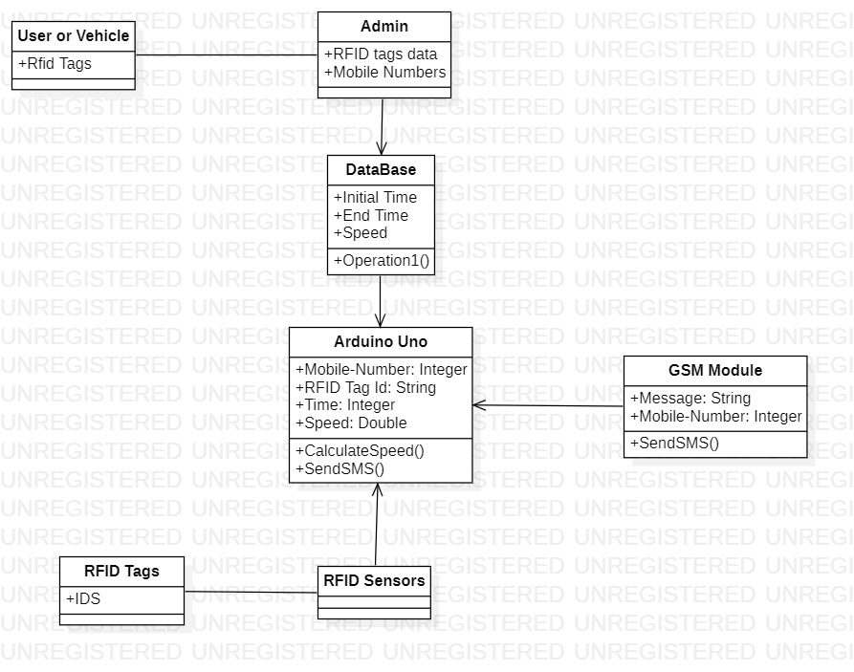

**4.3: Use case Diagram**

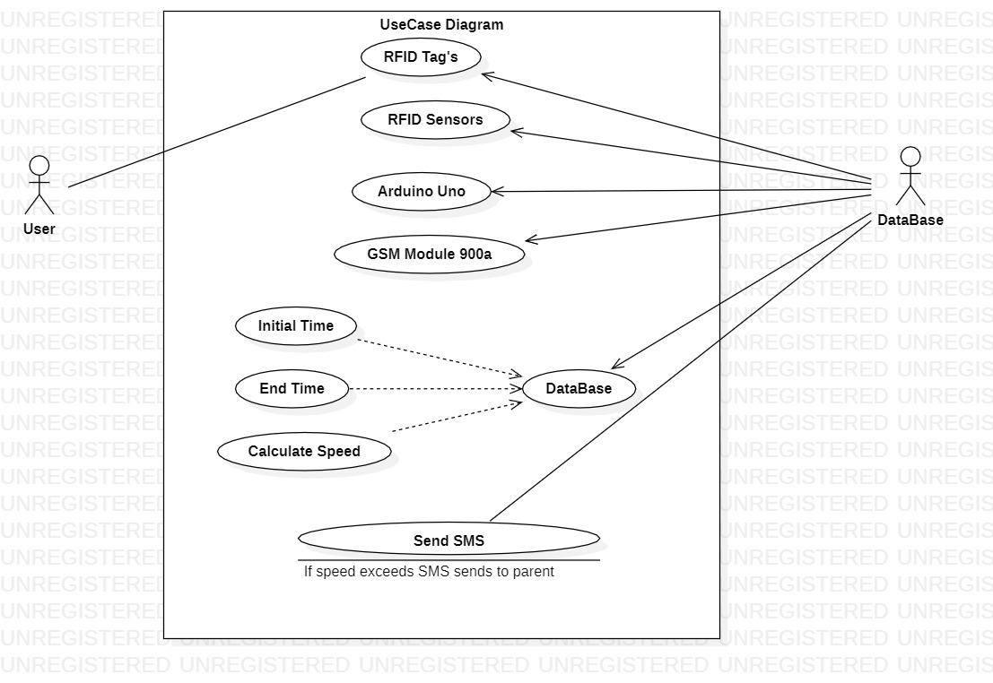

**4.4: Activity Diagram**

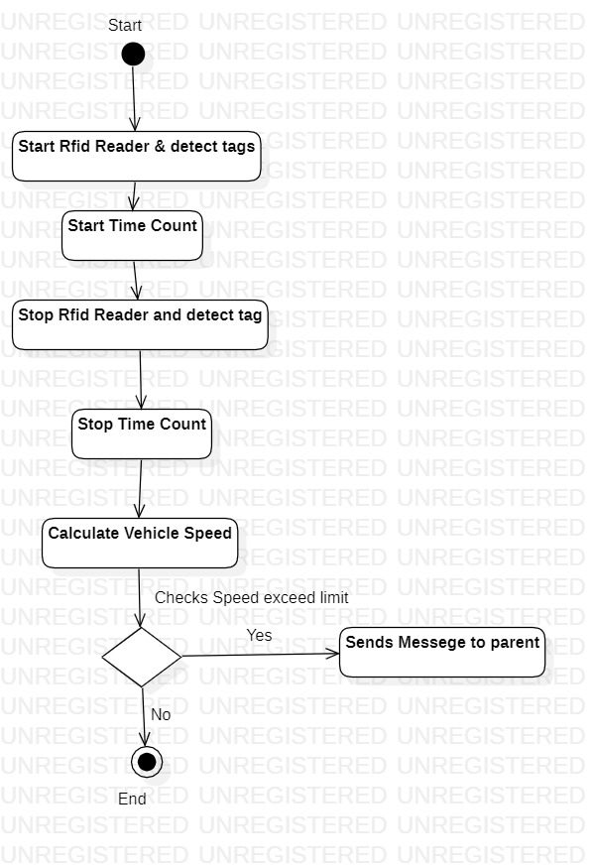

**4.5: Sequence Diagram**

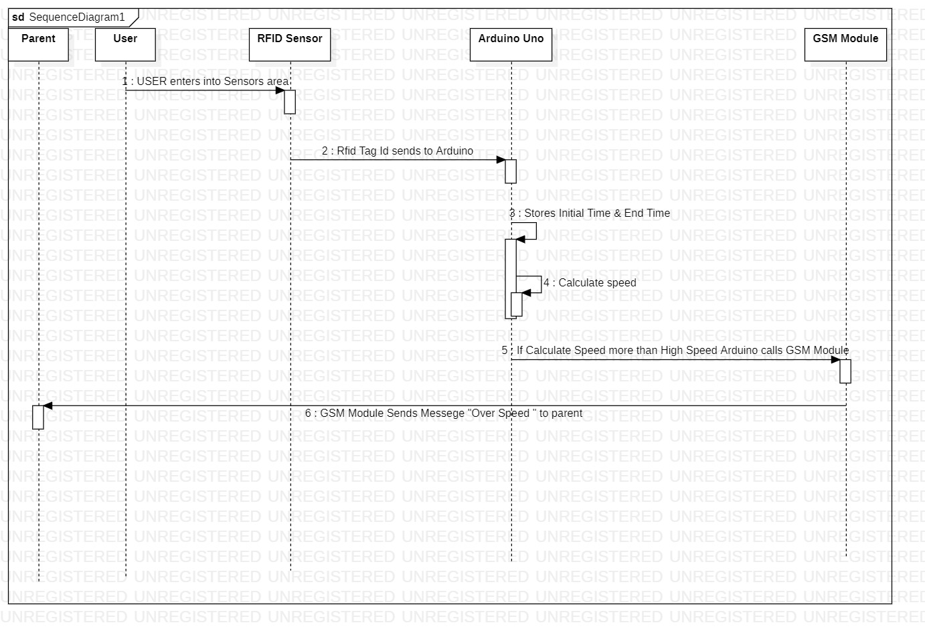

**4.6: System Architecture**

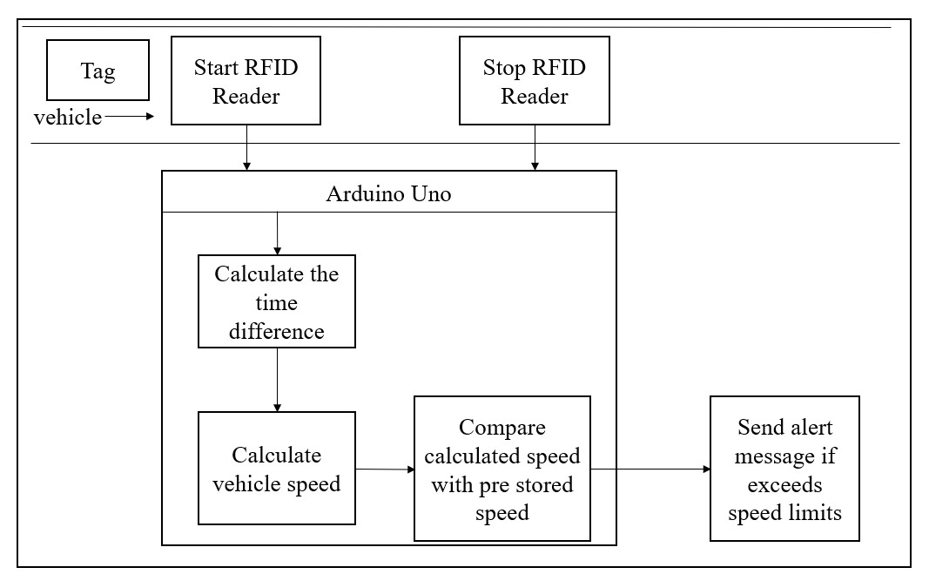

**4.7: Technology Description**

**CHAPTER 5: Implementation and Testing**

* 1. **: Hardware Setup**
     1. **: Arduino Uno with RFID readers**

The entire system of this project generally involves Arduino Uno. The two RFID readers (MFRC522) were connected to Arduino Uno by using jumper cable to perform read function for the system. The wire connection for start RFID reader is as table 5-1-1- T1. The wire connection for stop RFID reader is as table 5-1-1-T2. Besides that, a figure of Arduino Uno pin diagram and the actual setup with RFID readers are also shown.

|  |  |
| --- | --- |
| RFID reader (Start) | Arduino Uno |
| 3.3V | 3.3V |
| RST | Arduino Pin 9 |
| GND | GND |
| MISO | Arduino Pin 12 |
| MOSI | Arduino Pin 11 |
| SCK | Arduino Pin 13 |
| SDA (SS) | Arduino Pin 10 |

*Table 5-1-1-T1: Wire Connection for start RFID reader*

|  |  |
| --- | --- |
| RFID reader (Stop) | Arduino Uno |
| 3.3V | 3.3V |
| RST | Arduino Pin 7 |
| GND | GND |
| MISO | Arduino Pin 12 |
| MOSI | Arduino Pin 11 |
| SCK | Arduino Pin 13 |
| SDA (SS) | Arduino Pin 8 |

*Table 5-1-1-T2: Wire Connection for stop RFID reader*

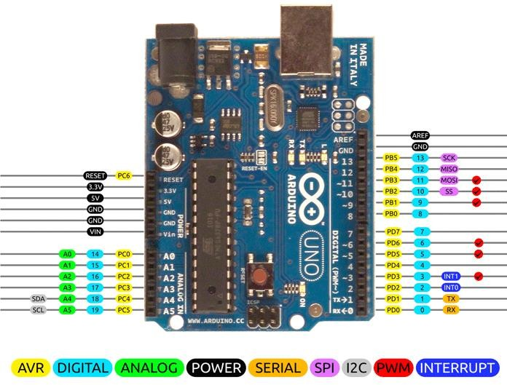

*Figure 5-1-1-F1: Arduino Uno pin diagram (Component101, 2018)*

**5-1-2: Arduino Uno with GSM SIM 900a**

In this project, GSM SIM 900a is controlled by Arduino Uno to send message to the mobile phone if the vehicle exceeds the speed limit. This GSM SIM 900a was connected to the Arduino Uno by using jumper cable. The wire connection for the GSM SIM 900a is as table 5-1-2. Besides, the actual implementation of the GSM SIM 900a is also shown.

|  |  |
| --- | --- |
| GSM modem | Arduino Uno |
| GSM Rx | Arduino Pin 2 |
| GSM Tx | Arduino Pin 3 |
| GND | GND |
| 5V | 5V |

*Table 5-1-2-T1: Wire Connection for GSM modem*

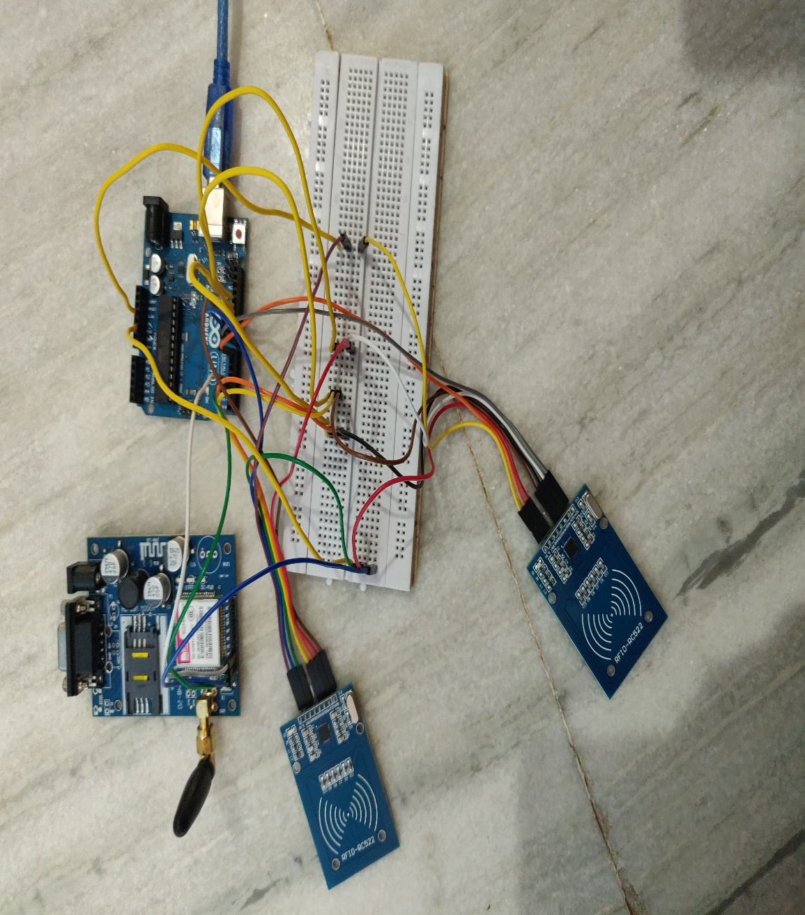

*Figure 5-1-2-F1: Actual setup with Arduino Uno, RFID Readers & GSM SIM 900a*

**5-2: Software Setup**

* + 1. **: Arduino Software (IDE)**

In this project, Arduino Software (IDE) need to be installed in the laptop in order to write the code and upload the code to the Arduino Uno board. Arduino IDE is written in programming language JAVA and is a cross platform application which can make the user easy to write code and upload the code to the Arduino Uno board. The installation of the Arduino Software (IDE) is short and the guide is easy to find online. The Arduino Software (IDE) that we used in this project is the latest version which is Arduino 1.8.15. The available installation guide for Arduino Software (IDE) can be find in the following link: (<https://www.arduino.cc/en/Guide/Windows>). There are total of 7 mechanisms we can install the Arduino Software (IDE):

* + - * Windows Installer
      * Windows ZIP file
      * Windows app
      * Mac OS X
      * Linux 32 bits
      * Linux 64 bits
      * Linux ARM

In this project, we are installing the Arduino Software (IDE) Windows Installer. Windows Installer can install directly everything we need to use in the Arduino Software (IDE), including the drivers. After the installation is completed, we can start to install the libraries and run the program.

**5-2-2: RFID Library**

RFID library need to be installed in the Arduino Software (IDE) in order to read the data from the tag. The RFID library can be download from this link: (<https://github.com/saishankar47/RFID>). After downloaded, unzip the RFID-RC522- master.zip file and install it in the Arduino Software (IDE).

**5-2-3: GSM Library**

In this project, GSM library is installed to allow Arduino Uno to control the GSM modem in order to send message to the mobile phone.

**5-3: System Operation**

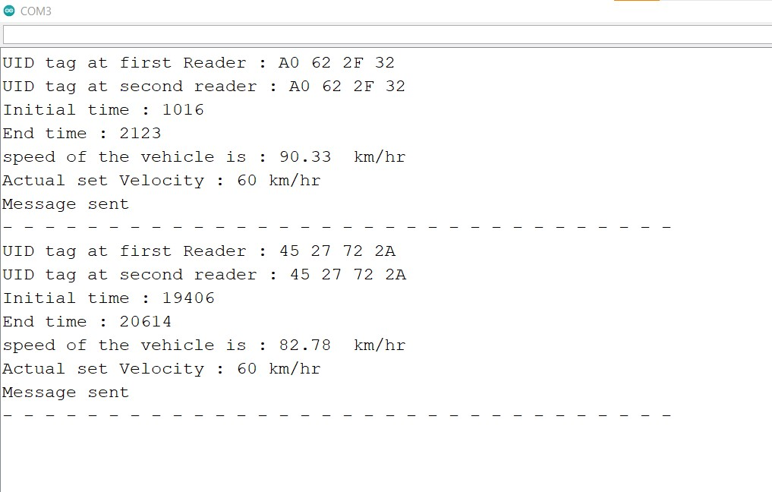

*Figure 5-3-F1: Screenshot for retrieve UID from RFID reader*

Once all the components are connected to the Arduino Uno board and the required libraries are installed in the Arduino Software (IDE), the system is able to run according to the C++ script which uploaded to the Arduino Uno board. The first function in this project is collecting data from the two RFID readers. When the vehicle pass through the start RFID reader, the unique ID of the tag will retrieve from the start RFID reader and display on the serial monitor. When the vehicle pass through the stop RFID reader, the unique ID of the tag will retrieve from the stop RFID reader and display on the serial monitor.

The second function in this project is calculating the vehicle speed. Every time the vehicle pass through the start RFID reader, the time count will start. The start RFID reader will become unable to scan for the other vehicle until the first vehicle pass through the stop RFID reader. When the vehicle pass through the stop RFID reader, the time difference for a vehicle to pass through the two consecutive readers in milliseconds or seconds(Converted) will display on the serial monitor. Formula to calculate the speed is detected speed = distant / ((time stop - time start) / 1000.0). The reason that divided the time difference by 1000.0 is because 1 second is equal to 1000 milliseconds. By using this formula, the vehicle speed is calculated.

After that, the calculated speed is compared with the limit speed should be drive the vehicle. If the calculated speed is exceed it limits, The third function (For GSM Module) is called to send the text message to the parent related the speed limit (Over Speeding).

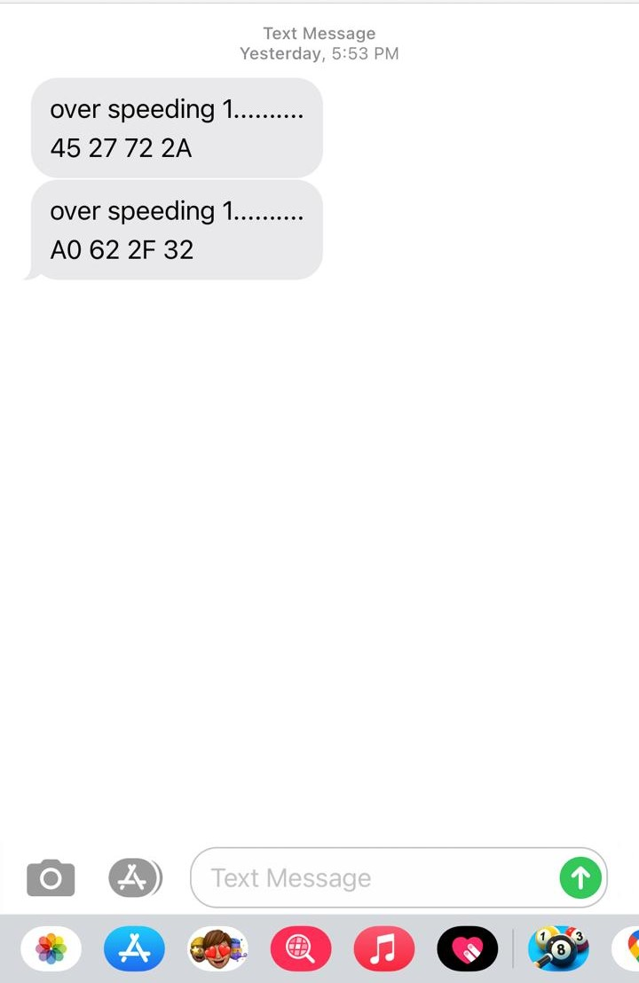

*Figure 5-3: Screenshot of phone Message*

The above image (Fig 5-3) shows the phone message when the vehicle exceeds the speed limit.

**CHAPTER 6: Conclusion & Future scope**

In this way using UHF (ultra-high frequency) RFID (Radio Frequency ID) readers, we can ensure that every user can be tracked and every parent can be informed prior about over speeding with the active participation of the parents we can reduce the road crashes as most of the accidents are caused because of over speeding. Even we can collaborate with the Government of Telangana Transport Department and can send details to the head office of overspeed students so that appropriate fines also be charged over them which makes the students as well as the parents more cautious.

**References**

* Arduino Software: <https://www.arduino.cc/en/software>
* RFID Library: <https://github.com/saishankar47/RFID>